**Augmentation in Object Detection**

#### The goal of image augmentation is to artificially increase the size of your training image dataset by generating modified copies of the original images.

#### **Some of the standard image augmentation techniques :**

#### Rotating an image clockwise or anticlockwise by a given angle

#### Flipping an image vertically or horizontally

#### Brightness adjustment by increasing or decreasing image brightness

#### Noise addition by applying blurring effects (e.g., Gaussian blur)

#### Scaling image inwards or outwards for different degrees of zoom

#### **Albumentations:**

* + [YOLOv5](https://github.com/ultralytics/yolov5) 🚀 is now fully integrated with [Albumentations](https://github.com/albumentations-team/albumentations), a popular open-source image augmentation package.

#### **Mosaic Augmentation**

#### Detection results of the YOLOv5 model is mosaic augmentation.

* + YOLOv5 🚀 applies online imagespace and colorspace augmentations in the trainloader (but not the val_loader) to present a new and unique augmented [Mosaic](https://github.com/ultralytics/yolov5/blob/90b7895d652c3bd3d361b2d6e9aee900fd67f5f7/utils/datasets.py#L678-L732) (original image + 3 random images) each time an image is loaded for training. **Images are never presented twice in the same way**.

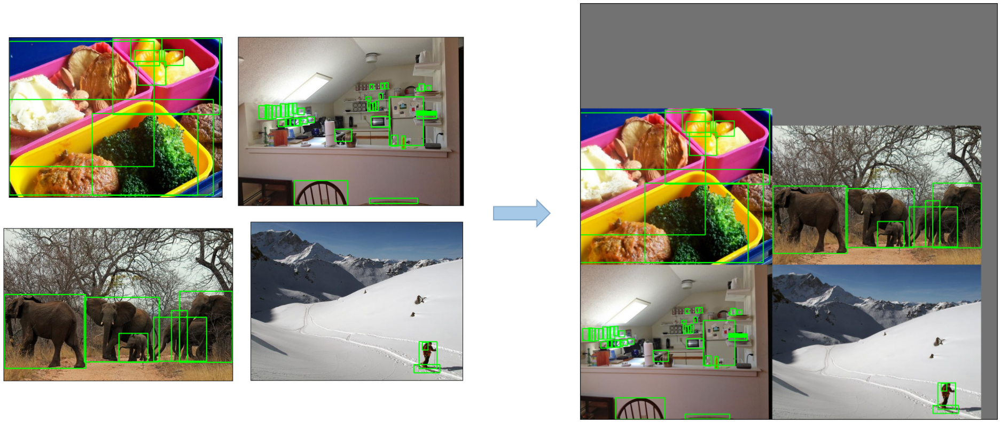

* **Copy paste**

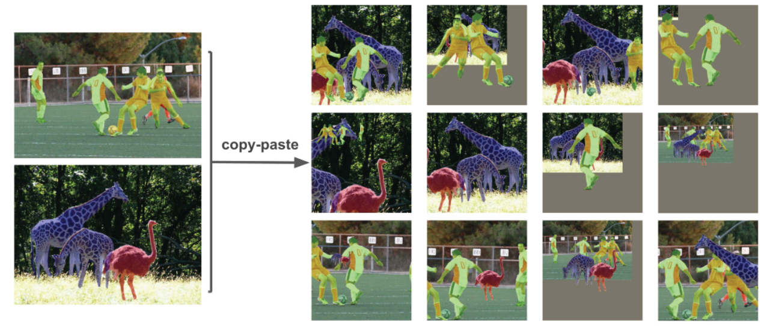

* **Random affine(Rotation, Scale, Translation and Shear)**

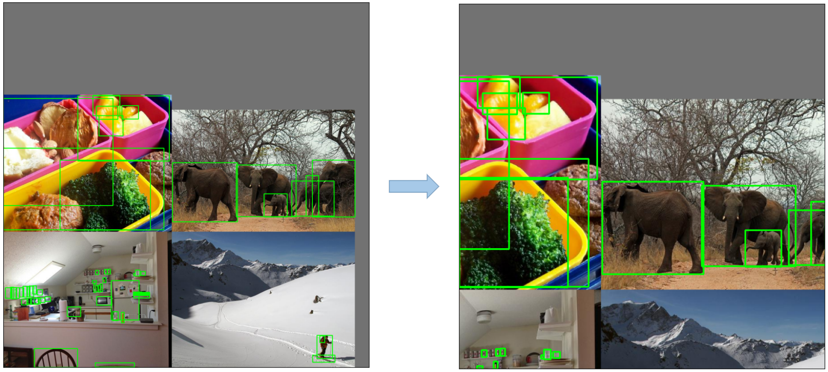

* **MixUp**

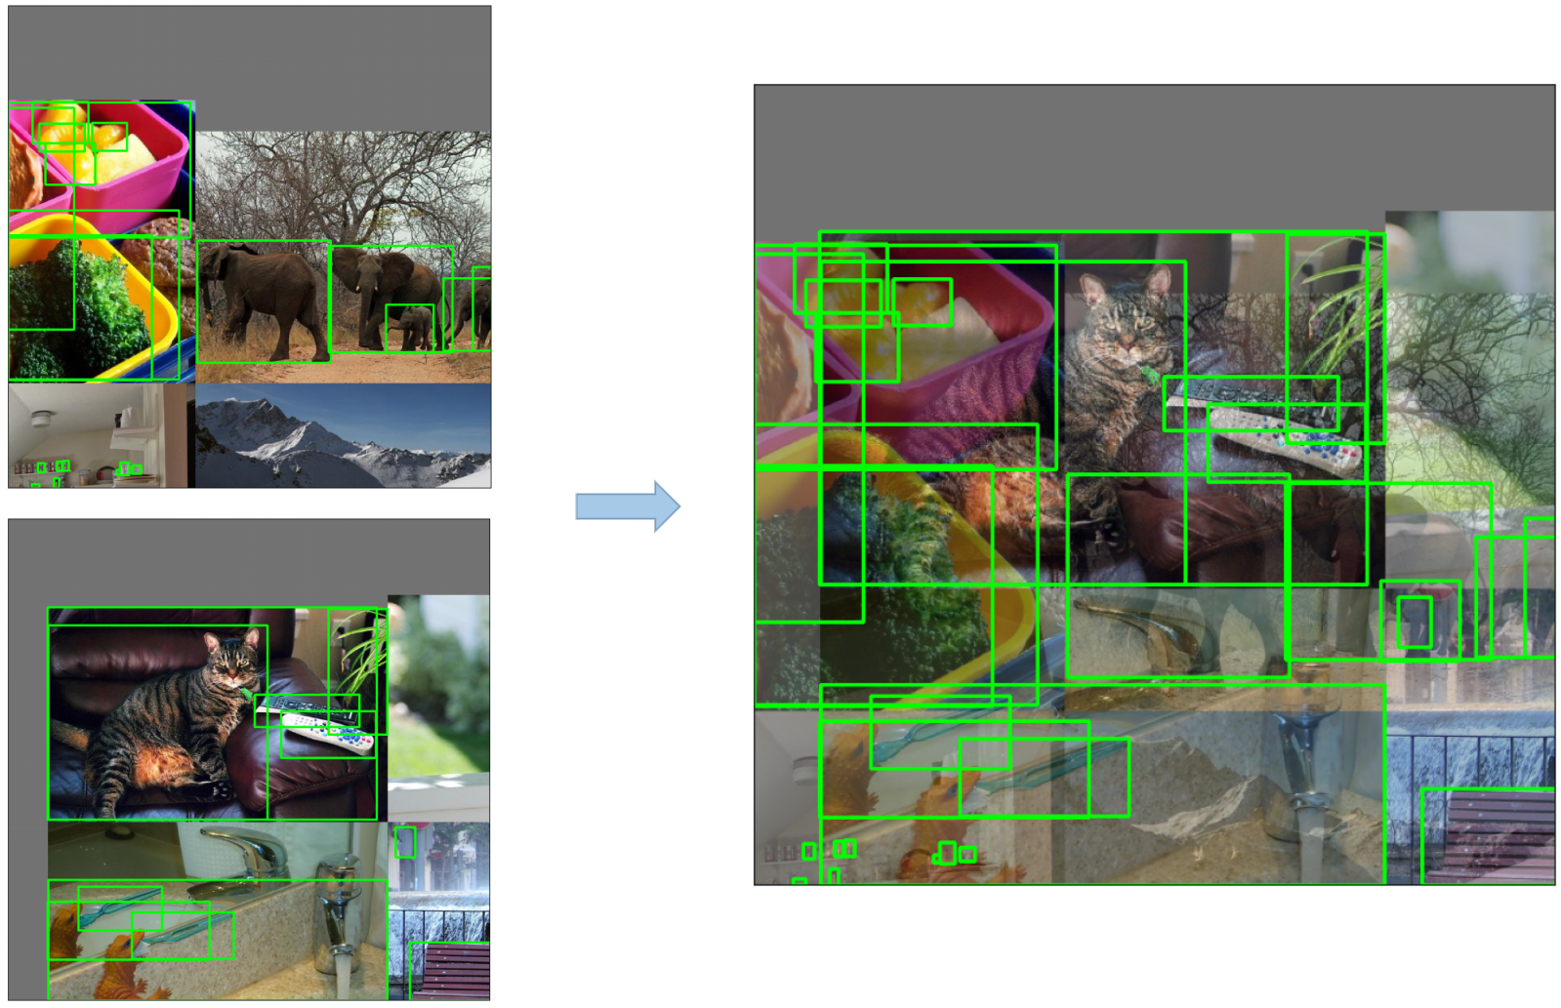

* **Augment HSV(Hue, Saturation, Value)**

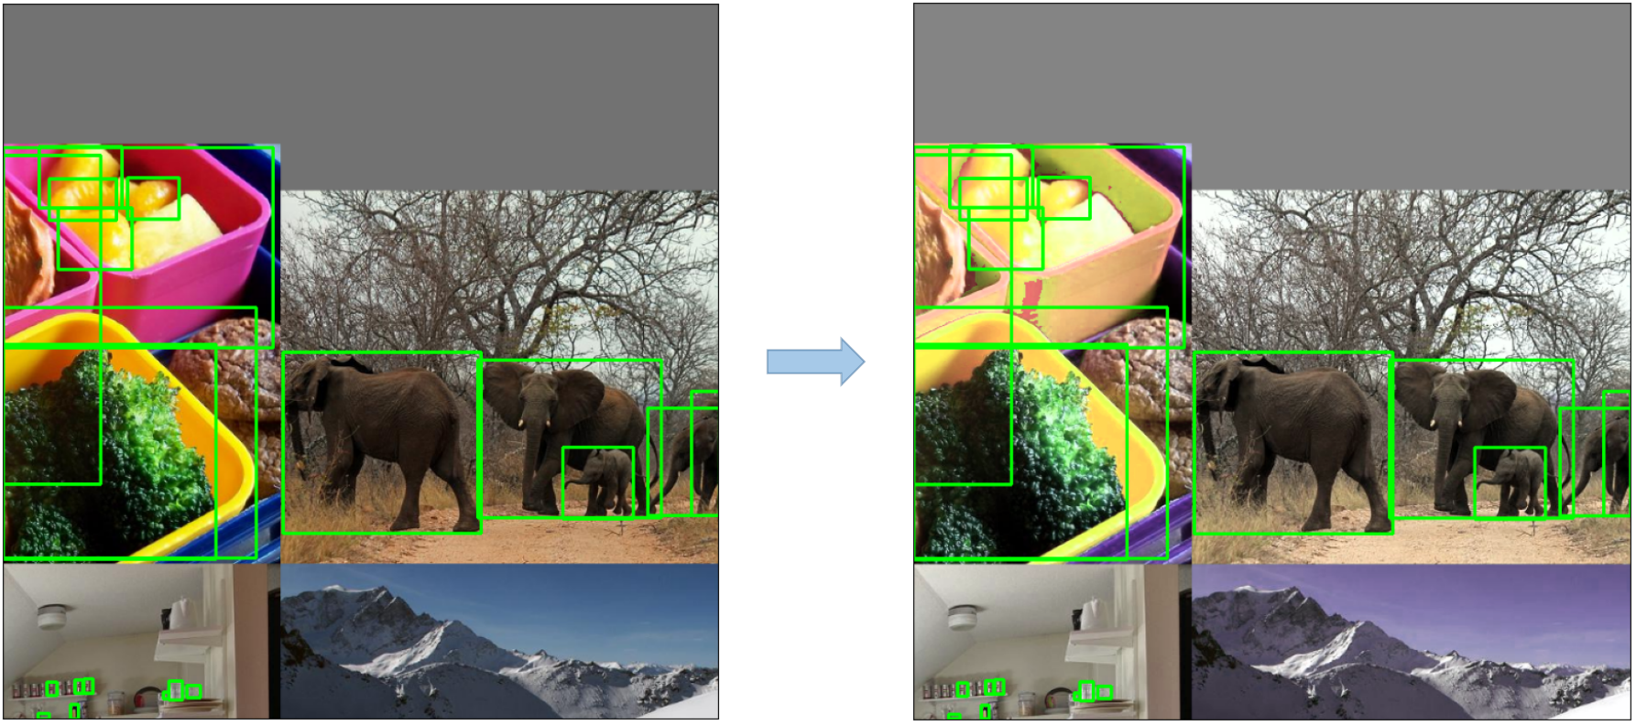

* **Random horizontal flip**

